­

Dynatrace: Hands-on



Table of Contents

Non-Disclosure 3

Scoring 3

Time & Allowed Materials 3

Preparation 3

1. Configure Process Group Detection Rules (5 Points) 4

2. Configure Application Rule (5 Points) 5

3. Configure URL Renaming Rule (5 Points) 6

4. Configure User Action Naming Rule (5 Points) 7

5. Configure Custom Service Naming Rule (5 Points) 8

6. Create a Web Request Naming Rule (5 Points) 9

7. Capture Web Request Parameters (10 Points) 10

8. Analyzing Backtrace using Filters (10 Points) 11

9. Create easyTravel Dashboard (20 Points) 12

10. Optimize Dynatrace Deployment (6 Points) 13

11. Customer Questions (24 Points) 14

12. Create and submit (required to pass exam) 15

Preparation

1. **Install** the easyTravel demo application + OneAgent Service
2. **Launch** easyTravel GUI Launcher
3. **Start** the UEM – Standard Scenario
4. **IF** you have problems from within the Dynatrace network, disable Third-Party Problems and VPN. Be on Dynatrace-Yellow.

## Configure Process Group Detection Rules (5 Points)

Create a **new** process group detection rule identifying easyTravel processes using the command line args:

* The initial detection rule can be using the JAR file name
* The extraction rule should be early on in the command line args

Paste the detection rule below.

|  |
| --- |
|  |

Restart the processes and show the detection rule working. Paste the screenshot below.

|  |
| --- |
|  |

## Configure Application Rule (5 Points)

Head into the global settings. Configure an application rule that will resolve all localhost requests to an application called “[www.easytravel.com](http://www.easytravel.com)”

Paste a screenshot of the rule below.

|  |
| --- |
|  |

## Configure URL Renaming Rule (5 Points)

I would like all of the <http://localhost:8079> URLs to be replaced with www.easytravel.com. Therefore, the resulting URLs would appear like this:

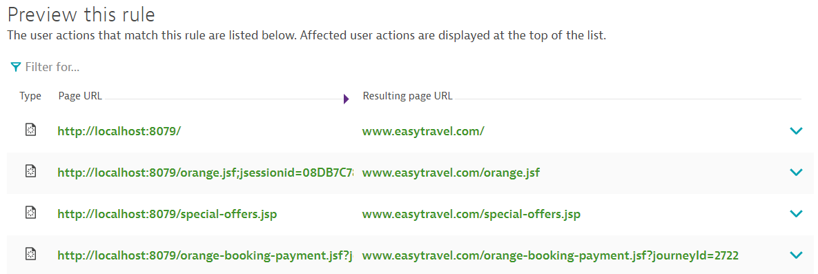

Please create the rule and paste your results below.

|  |
| --- |
|  |

## Configure User Action Naming Rule (5 Points)

I would like all of the orange-booking transactions to be baselined together.

Please create a user action naming rule that groups those three actions together.

Example: 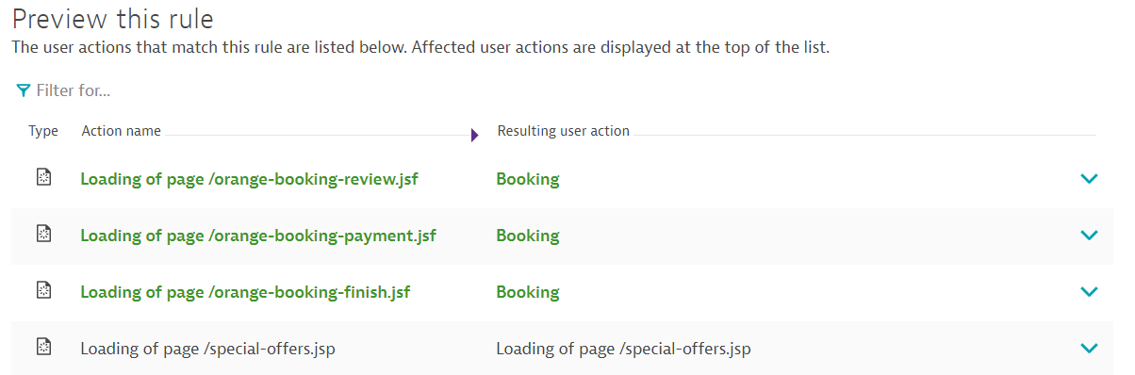

Paste your results below:

|  |
| --- |
|  |

## Configure Custom Service Naming Rule (5 Points)

Instead of “easyTravel Business Backend”, I want the service to be “your name easyTravel Business Backend”.

Please make the global config change, and paste your results below.

|  |
| --- |
|  |

## Create a Web Request Naming Rule (5 Points)

I would like all of my “/orange-booking-XXXXX.jsf” requests to appear as “Booking – XXXXX”

Example: 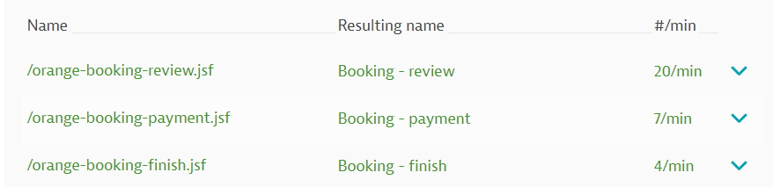

Please create this rule under the Customer Frontend service and paste your results below:

|  |
| --- |
|  |

Please also mark these 3 as key requests under the service and paste them showing up below as key requests:

|  |
| --- |
|  |

## Capture Web Request Parameters (10 Points)

Enable the capturing of easyTravel JourneyID’s. Head into the global settings for request attributes, and enable capture for all web request query parameters “journeyid”.

Please paste your rule and results below:

|  |
| --- |
|  |

## Analyzing Backtrace using Filters (10 Points)

Jump into the JourneyService. View all the requests and filter the requests that are called by easyTravel Customer Frontend.

Paste a screenshot below of the filter being applied.

It should look like this: 

|  |
| --- |
|  |

I want to know which call from the easyTravel Customer Frontend is calling findJourneys the most. Analyze the backtrace and make sure the Frontend is selected.

It should look similar to this: 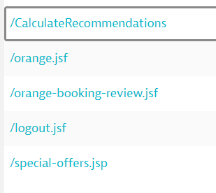

Copy a screenshot of the calls coming from the easyTravel Customer Frontend into the JourneyService.

|  |
| --- |
|  |
|  |

## Create easyTravel Dashboard (20 Points)

We want to create a final easyTravel dashboard with the configurations you have made. Your dashboard should be called “easyTravel” and look like the one below:

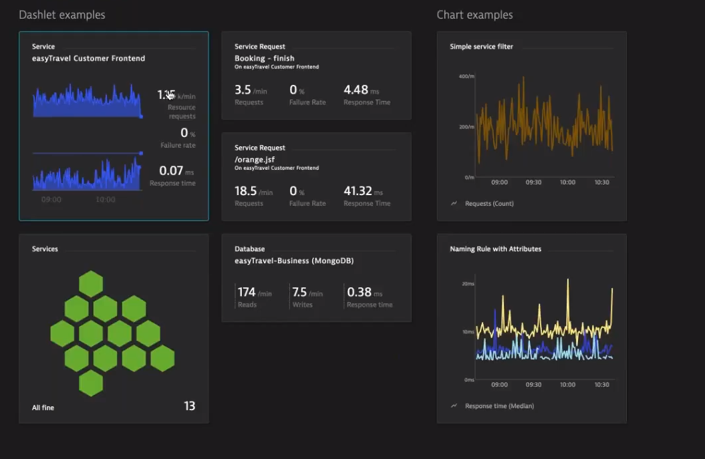

Keep in mind to use your marked key requests for the “Service Request” dashlets.

Also, please use the single service filter dashlet to filter requests to Journey Service.

Finally, please filter the “naming rule with attributes” chart to include only booking – payment, booking – review, and booking – finish.

Please paste your dashboard in the spot below:

|  |
| --- |
|  |

## Optimize Dynatrace Deployment (6 Points)

List at least 5 Best Practices to make Dynatrace deployment architecture & configuration production ready. More is better. Make it clear that you understand each point. Where possible, apply them to your deployment / installation.

|  |
| --- |
|  |

## Customer Questions (24 Points)

Please over-deliver on the answers. Make sure it’s clear you know the answer. Screen shots, if appropriate, help make it clear you know what you’re doing.

1. How are PurePaths and Tiers represented in Dynatrace? What does this allow us to do?

|  |
| --- |
|  |

1. Services represent what percent of typical use case Business Transactions out of the box?

|  |
| --- |
|  |

1. How are services created?

|  |
| --- |
|  |

1. Baselining and fault domain isolation is based off of what specifically?

|  |
| --- |
|  |

1. What is the purpose of a active gate?

|  |
| --- |
|  |

1. How does the OneAgent installation differ from Windows to Linux?

|  |
| --- |
|  |

1. How do I configure web checks in Dynatrace? Please list all the steps below.

|  |
| --- |
|  |
|  |

1. Are there still PurePaths within Dynatrace like AppMon? Paste an example below with an explanation.

|  |
| --- |
|  |

1. How do I update the OneAgent? Paste the options I have available below.

|  |
| --- |
|  |

1. How do I turn on additional modules within Dynatrace if the monitoring technology is not enabled by default?

|  |
| --- |
|  |

1. Where do I disable monitoring for certain programs in Dynatrace?

|  |
| --- |
|  |

1. Where can I enable, import, or create plugins within Dynatrace?

|  |
| --- |
|  |

**-------------------------------------------------------------------------------------------------**

**After you have completed all the other exercises…………..**

1. Paste your URL to your http://<tenant>.live.dynatrace.com environment below.

|  |
| --- |
|  |